Research Proposal

Dexter Watkins

# Introduction

The goal of this paper to detail the desired nature of my research and master’s thesis. First, the overall goals of my work are presented, along with design considerations and critical vehicle and satellite subsystems. In the following sections, my research goals are fleshed out and examples are given of how each design consideration and subsystem can be addressed.

My research goals are to:

1. Create a novel vehicle system that, for each identified subsystem, either:
   1. Implements a current state of the art process, design, or component
   2. Develops and implements a novel technique, process, or component
2. Develop a modular, hardware-in-the-loop simulation to act as a testbed for rapid satellite and spacecraft system design and verification.
3. Verify the system in a scenario using real life objectives, flight data, and events, such as an apollo mission or the use of a cubesat.

In order to achieve these goals, the following design considerations and subsystems must be addressed.

1. Orbital Mechanics and Astrodynamics
2. Power Systems
3. Propulsion Systems
4. Attitude Control Systems
5. Guidance, Navigation, and Control
6. Communications, Telemetry, Tracking, and Command
7. Distributed Real-Time Hardware-in-the-Loop Systems

# Goals

## Vehicle

The key to progress in space exploration is novel and efficient vehicle design. While it is definitely beyond my skills and my time available as a M.S. student to develop a completely new vehicle or system, I believe it is feasible to conduct a survey of current state of the art designs and techniques used in industry and combine it with proposed technology still under research in academia to present what “could be” in the near future.

## Simulation

Rigorous testing and simulation is needed in order to properly validate a spacecraft design. In order to perform this verification, I want to develop a modular, hardware-in-the-loop testbed. I expect this work to be the bulk of my research, and to be the “final product” presented in my master’s thesis.

The following figure details a preliminary testbed.

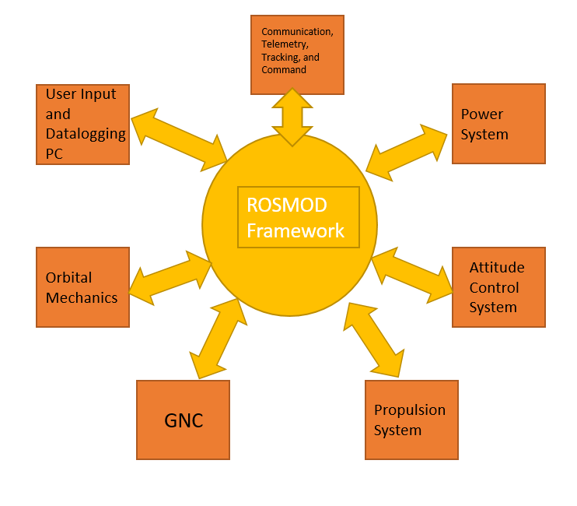

As can been seen, separate modules representing each subsystem communicate with each other, detailing their current state or sending commands and requests to other modules. A pc is used to provide user interaction and to log data as the simulation progresses. The modular nature of this simulation means that modifications can be made to a particular subsystem without interfering or affecting the internal behavior of other subsystems. More importantly, the modular nature of this system means that hardware-in-the-loop simulation can be performed.

Hardware-in-the-loop is a simulation technique *originating in the aviation industry* that allows for actual hardware, such as a guidance, navigation, and control computer, to be connected to a simulation, or “plant”. A mathematical representation is developed for all dynamic systems in the plant that affect the connected hardware. *In this way, from the hardware’s point of view,* *it is connected to a real life system and not a simulation*.

## Scenario

After the testbed is made, a scenario can be implemented to verify the design of spacecraft. This scenario can make use of real life data, such as the typical orbit and functionality of a cubesat, or re-enact the flight path of previous space missions, such as an Apollo lunar approach or a deep space vehicle’s flight path out of the solar system.

# Vehicle and Satellite Design Considerations

## Orbital Mechanics and Astrodynamics

**Description:** Astrodynamics studies the motion of space vehicles as influenced by celestial bodies, atmosphere(when applicable), and onboard propulsion.

**Sample Implementation:** Flight dynamics can be accurately simulated using a free space flight simulator called **Orbiter**. Orbiter uses realistic Newtonian physics, planetary motion, and gravitation effects (including non-spherical gravity) to accurately simulate vehicle motion.

Orbiter can act as the flight dynamics module of the proposed testbed, receiving vehicle state information (position, velocity, thrust, etc) and accurately predicting the state of the vehicle at the next time step for use by other modules.

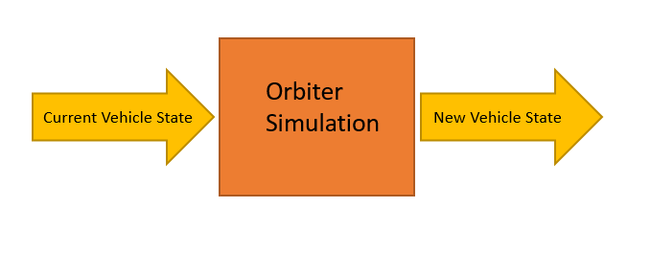

**References:**

<http://ocw.mit.edu/courses/aeronautics-and-astronautics/16-346-astrodynamics-fall-2008/>

<http://www.braeunig.us/space/orbmech.htm>

<http://orbit.medphys.ucl.ac.uk/faq.html>

<https://en.wikipedia.org/wiki/Orbiter_(simulator)>

## Power Systems

**Description:** The power system provides electricity throughout the vehicle. A means of power generation, distribution, and storage is needed. A power system must be optimized for mass, energy density, power cycles, and expected lifetime.

**Sample Implementation:** A solar array is simulated. Power input is determined from the vehicle’s current position and orientation. Solar energy is stored in batteries, which then power the system.

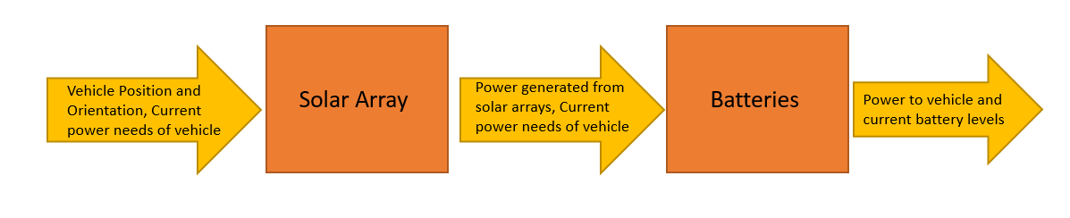

**References:**

Space Mission Engineering: The New SMAD, Wertz, Space Technology Library Vol 28, Microcosm Press

<http://www.lpi.usra.edu/sbag/meetings/jan2011/presentations/day1/d1_1200_Surampudi.pdf>

## Propulsion Systems

**Description:** In order to maintain or restore three-axis stability, to control spin, to execute maneuvers and make minor adjustments in trajectory, spacecraft are provided with sets of propulsive devices. These devices are typically of either the hypergolic bi-propellant type or the mono-propellant type. Many if the activities of the propulsion subsystems are routinely initiated by the attitude control subsystem. Some or all may be directly controlled by or through the command subsystem.

**Sample Implementation:** An ion thruster is controlled by the attitude and GNC subsystems. The thrust is then sent to the flight mechanics simulator to change the vehicles state

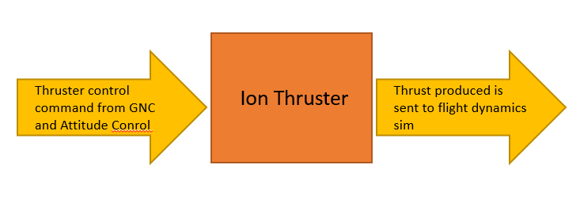

**References:**

Space Mission Engineering: The New SMAD, Wertz, Space Technology Library Vol 28, Microcosm Press

<http://www.braeunig.us/space/index.htm>

## Attitude Control Systems

**Description:** The purpose of the attitude control system is to stabilize and orient the vehicle during operation. Attitude is determined using sensors such as GPS and gyroscopes, and controlled using actuators such as reaction wheels and thrusters

**Sample Implementation:** An attitude control system receives the desired attitude from the GNC system and current orientation from a gyroscope. It then sends the appropriate commands to the propulsion system to adjust the attitude.

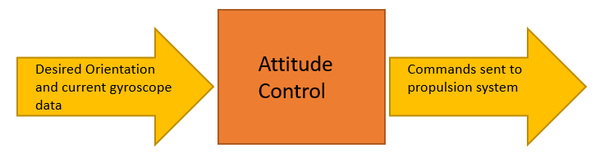

**References:**

Space Mission Engineering: The New SMAD, Wertz, Space Technology Library Vol 28, Microcosm Press

Spacecraft Systems Engineering, Fortescue, Wiley Publishing, 2011

## Guidance, Navigation, and Control

**Description:** A GNC system asks and answers three questions: Where do I want to go, Where am I now, and How do I get from where I am to where I want to be? A GNC computer will determine the trajectory of travel from the vehicles current location to a designated target, as well as desired changes in velocity, rotation, and acceleration for following that path. The GNC computer is also responsible for manipulating the vehicle for tracking guidance commands.

**Sample Implementation:** A GNC computer uses the vehicle’s current state and compares it to the desired state or position. Commands are then send to the propulsion and attitude control systems in order to achieve this state.

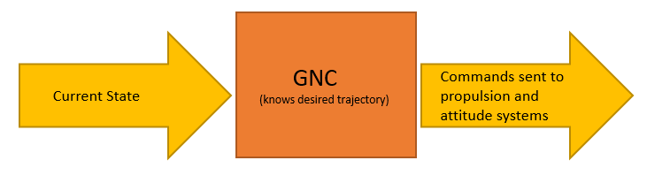

**References:**

Space Mission Engineering: The New SMAD, Wertz, Space Technology Library Vol 28, Microcosm Press

The Apollo Guidance Computer: Architecture and Operation**,** O’Brien, Springer Praxis

## Communications, Telemetry, Tracking, and Command

**Description:** The telemetry, tracking, and command subsystem provides the interface between the spacecraft and the ground systems, including carrier tracking, command reception and detection, telemetry modulation and transmission, ranging, and subsystem operations. A communications architecture is the arrangement of satellites and ground stations and the communications links that transfer information between them.

**Sample Implementation:** N/A I have not thought through how this would be implemented yet, but it is a critical system

**References:**

Space Mission Engineering: The New SMAD, Wertz, Space Technology Library Vol 28, Microcosm Press

## Distributed Real-Time Hardware-in-the-Loop Systems

**Description:** A distributed system is a system in which components are located on networked systems and communicate and coordinate their actions by passing messages. A real-time system processes data as it comes in, without any delays. It is useful for applications subject to a “real time constraint” such as an onboard guidance system. Hardware-in-the-Loop, as described earlier, enables actual hardware to be embedded into a testbed, and as far as the hardware is concerned is it operating in a real environment.

**Sample Implementation:** A distributed real-time hardware-in-the-loop system will be used to make the intended testbed. ROSMOD, as developed at ISIS, will be used to provide the framework for the system. Each vehicle subsystem, such as the GNC computer, the flight mechanics simulator, or the propulsion system, will be interconnected and able to communicate via message passing. This will provide a robust, real time verification of a vehicle system.



**References:**

<http://home.hit.no/~hansha/documents/lab/Lab%20Work/HIL%20Simulation/Background/Introduction%20to%20HIL%20Simulation.pdf>

<http://www.isis.vanderbilt.edu/sites/default/files/2015--RSP--ROSMOD%20-%20A%20Toolsuite%20for%20Modeling,%20Generating,%20Deploying,%20and%20Managing%20Distributed%20Real-time%20Component-based%20Software%20using%20ROS.pdf>